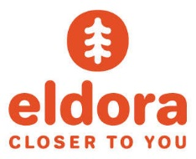
Because at Eldora, when Mother Nature needs help, we are ready!
Come join us!
Now Hiring Snowmakers for the 17/18 Season!
The perfect winter job…work hard when the resort’s closed and ski/ride all day when the resort’s open. Eldora is just 30 minutes west of Boulder.

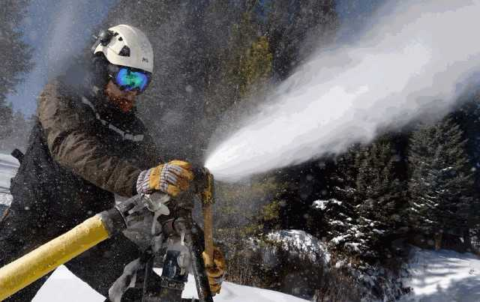
No Experience Needed. Job starts mid-October. All staff are eligible for a FREE Eldora ski pass, FREE lift tickets to many other Colorado and Powdr Resorts. Benefits also include 50% food, 40% retail discounts and more. Apply online now.
www.Eldora.com

