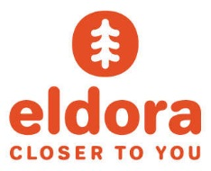
Because at Eldora, we love helping create new skiers and riders!

Now Hiring Ski and Snowboard Instructors for the 17/18 Season!
The perfect part-time job…work hard, ski/ride all weekend and have fun! RTD has & RT’s ldora (7 Round Trips every Sat / Sun)

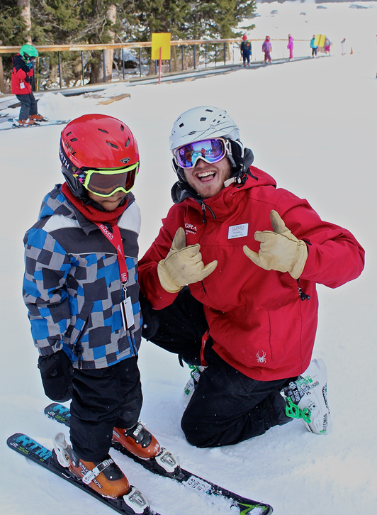

Skiers and Snowboarders welcome to apply. No Experience Needed. Most Jobs start after Thanksgiving. All staff are eligible for a FREE Eldora ski pass, FREE lift tickets to many other Colorado and Powdr Resorts. Benefits also include 50% food, 40% retail discounts and more. Apply online now. Come Join Us!
www.Eldora.com

