Because at Eldora, it’s all about special people in a special place…Come join us!
Now Hiring Winter Positions for the 17/18 Season!
The perfect winter job…Full and Part time positions available. Work hard, ski/ride for FREE and have fun! Regular RTD service from Boulder to Eldora.
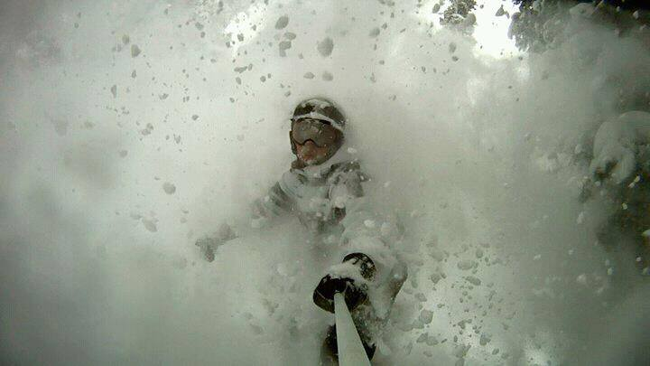
All staff are eligible for a FREE Eldora ski pass, FREE lift tickets to other Colorado and Powdr Resorts. Benefits also include Discounted dependent passes, 50% food, 40% retail discounts and more. Go to www.Eldora.com now to see open positions. Apply online now!

