PSIA - Rocky Mountain - AASI

Rocky Mountain Ski Instructors
Educational Foundation
P.O. Box 775143, Steamboat Springs, CO 80477
Phone: (970)879-8335 FAX: (970)879-6760; website: www.psia-rm.org
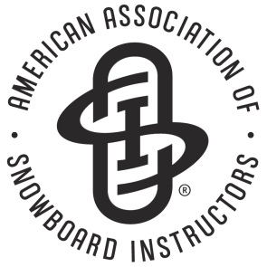

Membership and Events Logistics Coordinator Job Description

Job Summary:
To coordinate logistics of all events which include: setting up events online, creating and coordinating event accounting codes, staff lodging, meeting space, parking, and food while assisting with member needs and records on a daily basis.

Reports to:
Director of Education

Works closely with:
Executive Director
Director of Operations
Events and Membership Manager
Registrar
Education Staff

Major Responsibilities
- Securing and negotiating contracts for hotel and meeting rooms
- Assisting with the coordination of the events calendar
- Setting up events along with accounting codes online based on calendar
- Communicating event information to participants and staff through email and online confirmations
- Create and build reports for event management system
- Design and publish monthly e-newsletter
- Coordinate needs for events with committee chairpersons and Director of Operations, Director of Education and Events Registrar
- Prepare lift ticket count for ski schools hosting events
- Maintain online status of events
Additional Daily Responsibilities
- Book lodging for staff
- Print ID cards
- Track event packets and materials
- Answer Phones
- Work closely with National on database setup and training
- Diplomatic handling of policy and membership matters
- Attend events as necessary as office support or to gain insight into processes
- Communicate and problem solve membership inquiries through the most efficient service channel
- Support and consult the Executive Director and administrative team on all facets of the organization

The duties are not inclusive to the above description and may vary based on the needs of the organization.

