ADAPTIVE EXAM GUIDE for
ASB Stand-up Physical Disabilities
Revision 5-2019

The information in this document is provided only as a guideline. Although every effort has been made in preparing and assembling this guideline, with a goal of providing timely, complete, and accurate information, PSIA makes no claims, promises, or guarantees about the timeliness, accuracy, completeness, or adequacy of the contents of this guideline, and PSIA assumes no liability or responsibility and expressly disclaims liability for any errors and omissions in its contents
Local regulations and safety guidelines take precedence over this information. It is in your best interest to exercise due diligence in determining the appropriateness of the information for your particular circumstances. In addition, please take into account any and all factors that may affect your lesson. This includes but is not limited to: the health, well-being and fitness of the student; weather conditions; terrain; other people on the slope; your own abilities, as well as those of your student and anyone who may accompany you.
This guideline provides diagrams from third party sources. The content of any such third-party diagrams are not within our control, and we cannot and will not take responsibility for the information in them, nor should any references to them be considered any endorsement by PSIA.
Please refer to the Adaptive Alpine Manual, available through PSIA/AASI-RM or PSIA/AASI National: http://www.thesnowpros.org/shop/catalog/details?productid=%7B7E0BC90B-4972-45FA-8C89-E8C432745502%7D and all the addendums available to it. Especially useful should be the “Disability and Medication” one schedule to be online fall 2019 where you can find much more of the disability information and Snow sport specific comments. Also helpful are online Adaptive-specific courses offered through https://members.psia-rm.org/events/events-listing

This classification includes stand-up riders who might use adaptive equipment in conjunction with their snowboard. Adaptive equipment might include, but is not limited to outriggers, Riderbar, Hoola-hoop or Ski-pal, Bamboo pole, harness, tethers, board clamps, Kahuna Stick,

Types of Disabilities common to riders with Stand-up Physical Disabilities
As in other adaptive riding classifications, this category includes a varied and vast population. Some examples of disabilities included in this classification are:
- Amputations
- Limb Salvage & Deficiencies
- Balance impairments
- Cancer
- Cerebral Palsy (CP)
- Cerebrovascular Accident (CVA/stroke)
- Congenital anomalies of hip/leg/foot
- Epilepsy
- Multiple Sclerosis (MS)
- Muscular Dystrophy (MD)
- Paralysis & Paresis
- Polio & Post Polio Syndrome
- Spina Bifida
- Spinal Cord Injury
- Traumatic Brain Injury (TBI)

Evaluation of Student

A complete and detailed student evaluation is needed to determine if the student is candidate for stand-up riding. A primary concern with these disabilities is the physical assessment: range of motion, strength of limbs, balance and amount of ankle, knee and hip flexion available.

Your student’s goals and other disability involvements should be discussed during this evaluation. The evaluation indicates a base line of the equipment needed to create a successful learning environment. After the initial evaluation adjustments may need to be made due to student’s abilities demonstrated during the lesson or other factors.

In addition to the physical analysis, a personal evaluation should also take place to determine the students goals, other activities participated in, motivations and fears. This provides a platform from which to design the lesson plan. Determination of learning preference is ongoing throughout the assessment process and during the lesson. The student's learning preference should be matched with a complementary teaching style and an acceptable pace, which is based upon the physical analysis, personal interview snow conditions . . . .

During the student evaluation, some key considerations for Amputees:
- When the amputation occurred.
- Will your student ride with a prosthetic leg? Is this a sport specific leg and how does it function?
- If they will ride (or Ski-Bike) without their prosthetic limb, what is the present condition of the residual limb, is it properly wrapped and padded.
If the student has an Ideo-Brace, Limb Salvage or internal prosthetic questions relative to circulation, feeling and ability to control movements need to be asked.

The student evaluation should always include a review of medications:
Insulin, chemotherapy, radiation, anticoagulants and analgesics are some commonly encountered medications in the physical stand-up specialty. Some medications increase fatigue levels, others increase sensitivity to sun. Exploration and research of medications currently in use provides some insight into their effects upon the student. Also, be aware that the side effects from chemotherapy and radiation drugs can linger long after the drug therapy is complete.

Equipment Selection and Set Up
Additional adaptive or re-purposed equipment, physical assists and terrain selection all enhance flow of movements and the maintenance of balance in motion.

Outriggers, Bamboo poles or a Kahuna Sick and provide an additional point of balance. Outrigger height and brake adjustment are individual to the student, as is the choice of using one or two outriggers, either in the front or back hand. Beginners may have the outrigger bolt longer (more brake). Outrigger height should be adjusted to allow for an upright comfortable stance. As the student’s skills develop, dependency on this balance system decreases and outrigger height may be shortened and the bolt reduced (less brake).

A Rider Bar offers more support than outriggers but will severely limit the student’s ability to become an independent rider. The Rider Bar offers a more stable base of support for the rider and is adjustable for many riders. It allows the instructor to directly control the edges of the student’s board as well as to introduce Torsional twist of the board while assisting with balance and speed control through turn shape.

Other adaptive equipment, such as SB clamps, seat harness and tethers are often used to assist in the development of rotary movements. They can also assist with some speed control in the shaping phase of the turn on steeper terrain and other safety concerns. Tethers can be removed as the student progresses and can turn, control their equipment and speed, and stop safely.

Outriggers have lots of adjustments, so get to know them intimately before taking them out:
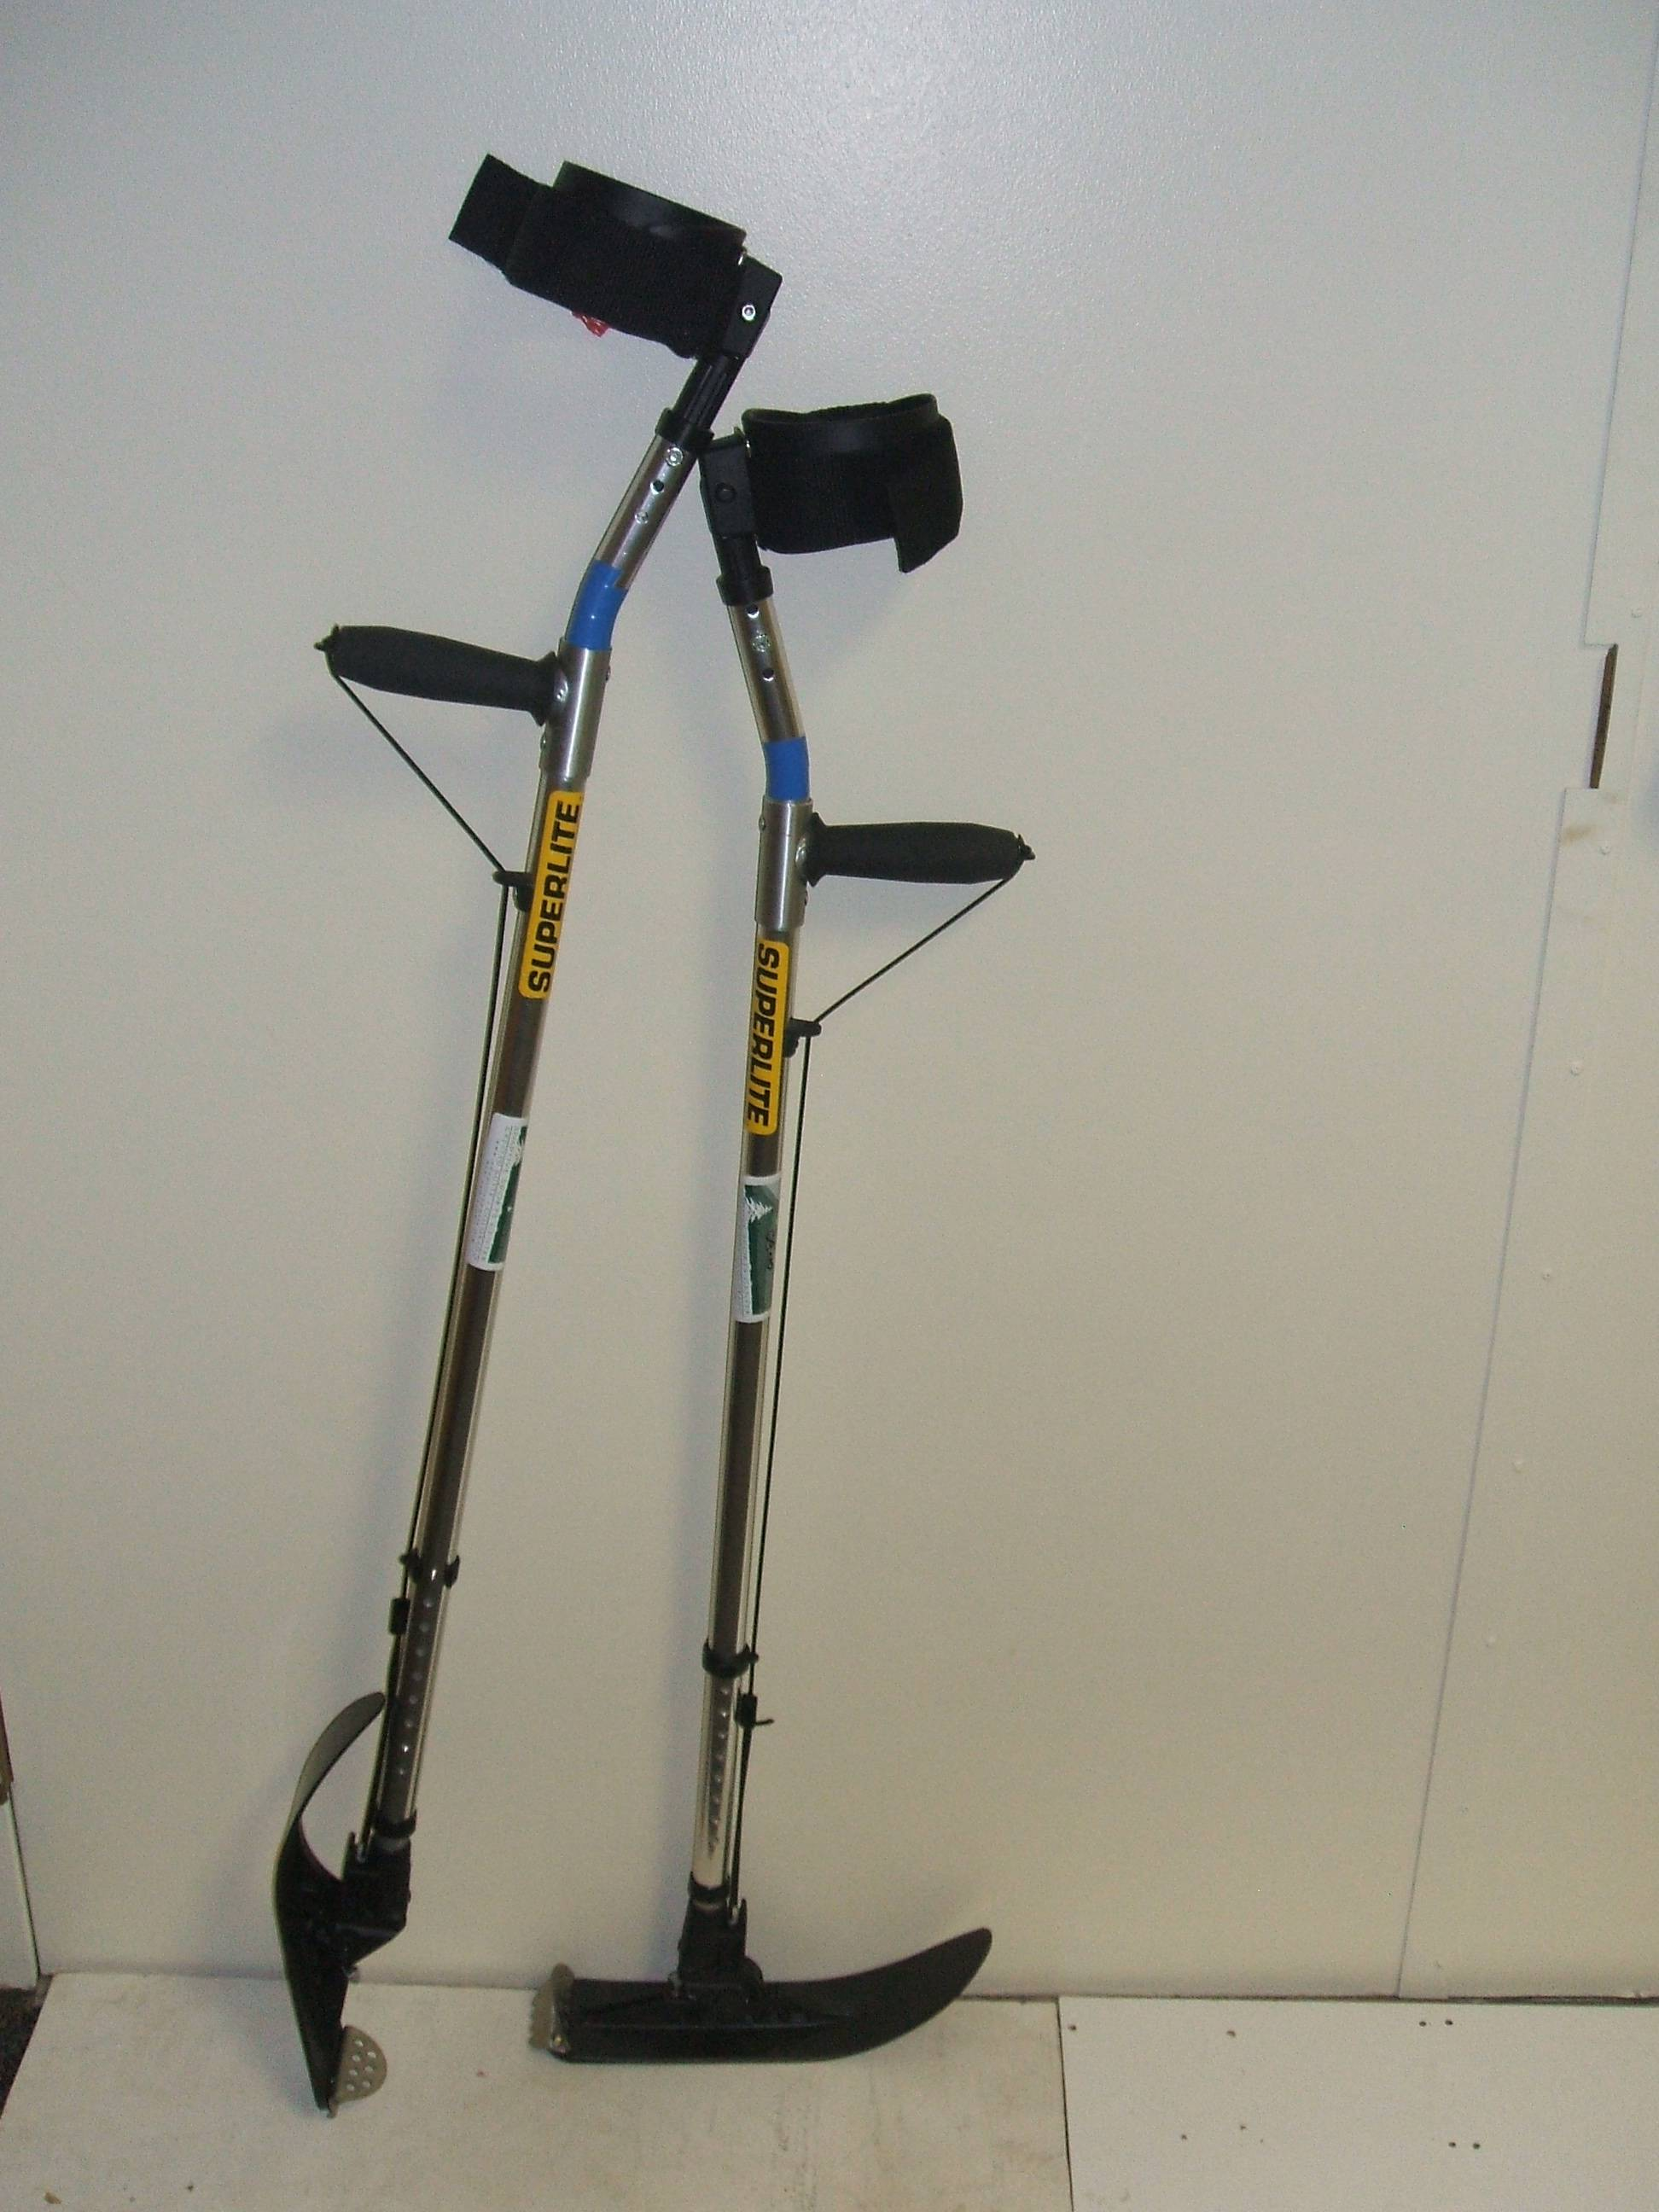
Cuffs
Ski
Claw
Outrigger in crutch position
Outrigger in ski position
Bolt – controls amount of brake
Cord – flips ski
Holes – adjust distance of cuff to handle
Holes – adjust height (ideally, leave two holes showing at top & bottom for on-hill adjustments)
Handle

Stand-Up Tethering
Stand-up tethering is an important assist technique that utilizes either a climbing seat harness to tether from your students hips or snowboard clips and tethers. Practice this before trying it with students as it takes skill and finesse to ensure safety and enjoyment for the student.

As the tetherer, you have the ability to:
- Assist with turns and turn shape - with active tethering in different parts of the turn
- Control speed - by utilizing the slope and through turn shape – NOT BY SIMPLY HOLDING YOUR STUDENT BACK AS HIS ANCOR!

By doing all of this, you can help a student create muscle memory and with enough practice, their newly developed skills should allow the student to eventually ride independently.

Remember that for safety. As a general rule, stand-up tethering is only appropriate on easy terrain (typically greens and easy blues).

Adaptive Stand-up Teaching Objectives
The following is based on the AASI Snowboard Teaching Handbook https://www.psia-rm.org/product/snowboard-teaching-handbook/
Please refer to the Handbook. Leave out exercises that do not make sense for your student or unnecessarily wear them out and focus on what the can do!
It is in your best interest to exercise due diligence in determining the appropriateness of the information for your particular circumstances. In addition, please take into account any and all factors that may affect your lesson. This includes but is not limited to: the health, well-being and fitness of the student; weather conditions; terrain; other people on the slope; your own abilities, as well as those of your student and anyone who may accompany you.

Beginner / Novice Zone Objectives
Level 1: Welcome to riding / Build the foundation
Level 2: Introduction Sideslipping and Direction Change
Level 3: Introducing Turning
Level 4: Refining Turns on Green Terrain
Intermediate Zone Objectives
Level 5: Exploring Movement Options and Terrain Variety
Level 6: Mastering Blue Terrain and Developing Versatility in Movemet

Expert Zone Objectives
Level 7: Introducing Black Terrain and Increasing Movement Intensity
Level 8: Mastering Black Terrain with active retraction
Level 9: Riding Anything, Anywhere in Any Condition

